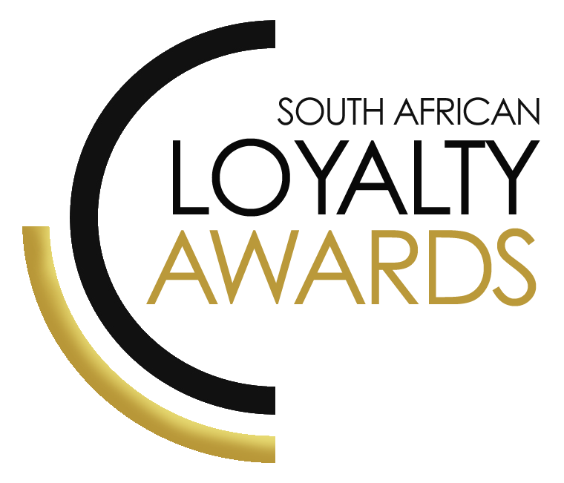
CATEGORY 15
BEST USE OF MULTI-CHANNEL LOYALTY COMMUNICATION / ENGAGEMENT INCLUDING
SOCIAL MEDIA
ENTRY FORM

ENTRY CONTACT INFORMATION:
Company name:
Contact name:
Job title:
Business email:
Telephone number:
Company logo:
Permission to enter the Loyalty Awards:
(Signature)
Signed by:
(Name & Surname)
Role:
Date:
SUMMARY:
This award will be awarded to recognise engagement/communication innovation across multiple channels. The brand must show impressive use of email, mobile & social within a loyalty initiative that takes advantage of the fast pace within the sector.
Please ensure your entries address the below criteria :
- ROI/ increased revenues/profits
- Connect with consumers on all of their favourite channels and multi-channel usage
- Increase consumer engagement and conversion rates
- Increase your customer base, lower customer acquisition costs
What we require :
- Entry contact information
- 1 Page executive summary
- Submission (max 3 pages)
- Supporting evidence files (max 5 items)
Entry fees:
A fee of R1 500 (ex VAT) is charged per category entry. Once you have submitted your entry, an invoice will be emailed to you. All entry fees must be paid in full before 1 June 2020.
All entries must be emailed to: info@southafricanloyaltyawards.com
Should your file sizes be too big for email, please share via dropbox or wetransfer.
AGENCY SUBMISSIONS (On behalf of clients)
If you are an agency and entering the awards on behalf of your client, you will need permission and sign-off from your client to enter their details for the awards. We require the signed agreement to accompany your entry. Please download the agency agreement here.

Please note: We will not review your entry if we have not received a signature from your client.
EXECUTIVE SUMMARY:

PROGRAMME DESCRIPTION:

RESULTS ACHIEVED:

THE NEXT 3 PAGES MUST HIGHLIGHT THE ACHIEVEMENTS IN THE FOLLOWING DELIVERABLES:

- Proven ROI/ increased revenues/profits
- Connect with consumers on all of their favourite channels and multi-channel usage
- Increase consumer engagement and conversion rates
- Increase your customer base, lower customer acquisition costs

Proven ROI/ increased revenues/profits:

Connect with consumers on all of their favourite channels and multi-channel usage:

Increase consumer engagement and conversion rates:

Increase your customer base, lower customer acquisition costs:

SAVING CRITERIA:
Once the above entry information has been completed, your files and supporting documentation must be saved in the following format when submitting your entry please:
file name = category#-programmename-brandname.doc
e.g. CATEGORY1-ROYALREWARDS-ROYALHOTEL.doc
Once you have saved all your files in the correct format, simply enter by emailing: info@southafricanloyaltyawards.com

If your file sizes are too big, simply send it to us via dropbox or wetransfer.
CONFIDENTIALITY:
To view our confidentiality agreement that has been signed by all judges and South African Loyalty Awards employees, please click here.
HAVE ANY QUESTIONS?
Give us a call on 021 761 48 10 or email info@southafricanloyaltyawards.com and we will gladly assist!

