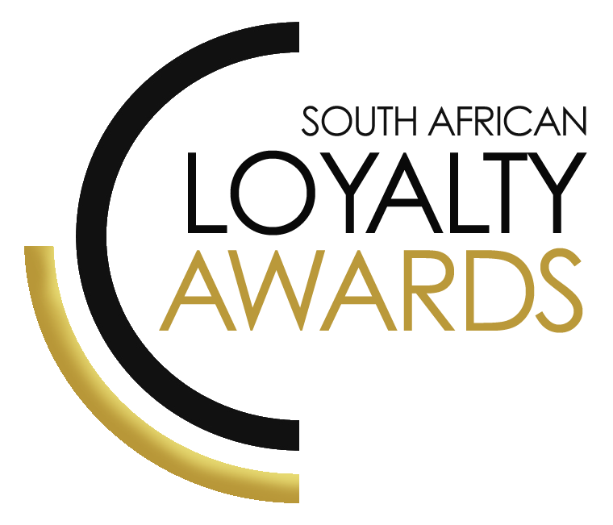
CATEGORY 6
BEST PROGRAMME OF
THE YEAR 2021:
SMALL MEDIUM ENTERPRISE
ENTRY FORM

ENTRY CONTACT INFORMATION:
Company name:
Contact name:
Job title:
Business email:
Telephone number:
Company logo:
Permission to enter the Loyalty Awards:
(Signature)
Signed by:
(Name & Surname)
Role:
Date:

SUMMARY:
This award will be awarded to the brand which demonstrates that it has operated the best loyalty offering in its sector, as an SME. The SME must show how they have achieved value to the customer, commercial benefits, ROI and customer engagement. SME size is as per SARS definition of R64m or less annual turnover.
Please ensure your entries address the below criteria:
- Commercial benefits for the brand
- Enhanced value for its customers
- Broader customer strategy approach
- Frictionless customer experience
What we require:
- Entry contact information
- 1 Page executive summary
- Submission (max 3 pages)
- Supporting evidence files (max 5 items)
Entry fees:
A fee of R1 750 (ex VAT) is charged per category entry. Once you have submitted your entry, an invoice will be emailed to you. All entry fees must be paid in full before 16 July 2021.
All entries must be emailed to: info@southafricanloyaltyawards.com
Should your file sizes be too big for email, please share via dropbox or wetransfer.
AGENCY SUBMISSIONS (On behalf of clients)
If you are an agency and entering the awards on behalf of your client, you will need permission and sign-off from your client to enter their details for the awards. We require the signed agreement to accompany your entry. Please download the agency agreement here.
Please note: We will not review your entry if we have not received a signature from your client.
EXECUTIVE SUMMARY:

PROGRAMME DESCRIPTION:

RESULTS ACHIEVED:

THE NEXT 3 PAGES MUST HIGHLIGHT THE ACHIEVEMENTS IN THE FOLLOWING DELIVERABLES:

- Commercial benefits for the brand

Please note:
The more factual statistics & results which you can give the judges, the more they can truly assess the success of this entry.
Please remember: everything is strictly covered by our confidentiality agreement.
- Enhanced value for its customers
- Broader customer strategy approach
- Frictionless customer experience

Commercial benefits for the brand:

Enhanced value for customers:

Broader customer strategy approach:

Frictionless customer experience:

SAVING CRITERIA:
Once the above entry information has been completed, your files and supporting documentation must be saved in the following format when submitting your entry please:
file name = category#-programmename-brandname.doc
e.g. CATEGORY1-ROYALREWARDS-ROYALHOTEL.doc
Once you have saved all your files in the correct format, simply enter by emailing: info@southafricanloyaltyawards.com

If your file sizes are too big, simply send it to us via dropbox or wetransfer.
CONFIDENTIALITY:
To view our confidentiality agreement that has been signed by all judges and South African Loyalty Awards employees, please click here.
HAVE ANY QUESTIONS?
Give us a call on 021 715 8619 or email info@southafricanloyaltyawards.com and we will gladly assist!

