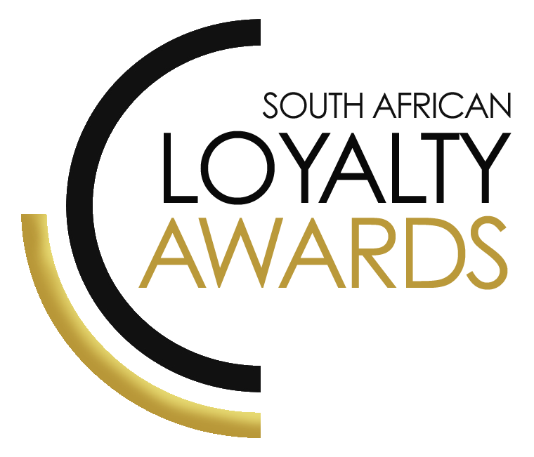
CATEGORY 13
BEST STRATEGIC USE OF DATA ANALYTICS / CRM APPLICATIONS
ENTRY FORM

ENTRY CONTACT INFORMATION:
Company name:
Contact name:
Job title:
Business email:
Telephone number:
Company logo:
Permission to enter the Loyalty Awards:
(Signature)
Signed by:
(Name & Surname)
Role:
Date:
SUMMARY:
This award will be awarded to the brand that demonstrates positive results, clearly derived from sophisticated use of customer data and the application in CRM or effective targeting and modelling, profitable customer segmentation, and proof of a deep analytical grasp of consumer attitudes and behaviours.
Please ensure your entries address the below criteria:
- Proven ROI/ increased revenues/profits
- Short-term campaign effectiveness
- Long-term customer-centricity approach
- Customer segmentation analytics driving results
- Proven retention
- Proven cross-sell / up-sell
What we require:
- Entry contact information
- 1 Page executive summary
- Submission (max 3 pages)
- Supporting evidence files (max 5 items)
Entry fees:
A fee of R1 500 (ex VAT) is charged per category entry. Once you have submitted your entry, an invoice will be emailed to you. All entry fees must be paid in full before 7 August 2020.
All entries must be emailed to: info@southafricanloyaltyawards.com
Should your file sizes be too big for email, please share via dropbox or wetransfer.
AGENCY SUBMISSIONS (On behalf of clients)
If you are an agency and entering the awards on behalf of your client, you will need permission and sign-off from your client to enter their details for the awards. We require the signed agreement to accompany your entry. Please download the agency agreement here.
Please note: We will not review your entry if we have not received a signature from your client.
EXECUTIVE SUMMARY:

DESCRIPTION OF ANALYTICAL / CRM USAGE

RESULTS ACHIEVED:

THE NEXT 3 PAGES MUST HIGHLIGHT THE ACHIEVEMENTS IN THE FOLLOWING DELIVERABLES:

- Proven ROI/ increased revenues/profits
- Short-term campaign effectiveness
- Long-term customer-centricity thought
- Customer segmentation analytics driving results
- Proven retention
- Proven cross-sell / up-sell

Proven ROI/ increased revenues/profits:

Short-term campaign effectiveness:

Long-term customer-centricity thought:

Customer segmentation analytics driving results:

Proven retention:

Proven cross-sell / up-sell:

SAVING CRITERIA:
Once the above entry information has been completed, your files and supporting documentation must be saved in the following format when submitting your entry please:
file name = category#-programmename-brandname.doc
e.g. CATEGORY1-ROYALREWARDS-ROYALHOTEL.doc
Once you have saved all your files in the correct format, simply enter by emailing: info@southafricanloyaltyawards.com

If your file sizes are too big, simply send it to us via dropbox or wetransfer.
CONFIDENTIALITY:
To view our confidentiality agreement that has been signed by all judges and South African Loyalty Awards employees, please click here.
HAVE ANY QUESTIONS?
Give us a call on 021 715 86 19 or email info@southafricanloyaltyawards.com and we will gladly assist!

