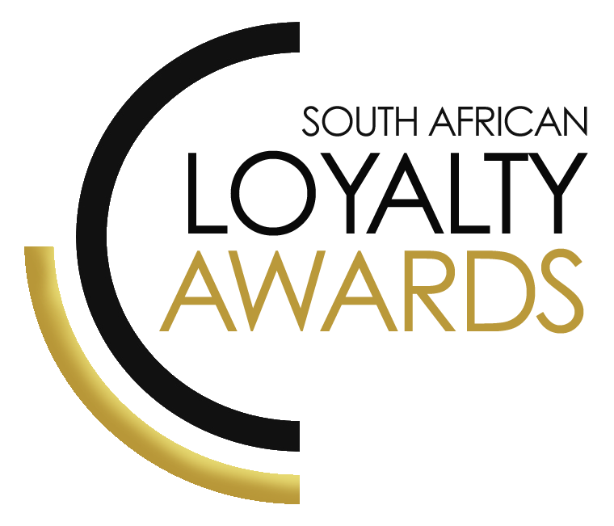
CATEGORY 11
BEST LOYALTY AGENCY
(MARKETING / REWARDS)
OF THE YEAR
ENTRY FORM

ENTRY CONTACT INFORMATION:
Company name:
Contact name:
Job title:
Business email:
Telephone number:
Company logo:
Permission to enter the Loyalty Awards:
(Signature)
Signed by:
(Name & Surname)
Role:
Date:

SUMMARY:
This award will be awarded to the best loyalty (marketing & rewards) agency in South Africa. Agencies are encouraged to submit their achievements in loyalty and CRM and for brands they have worked with in this environment. A demonstration of skills in loyalty marketing, CRM and rewards fulfilment to drive programme performance will be assessed.
Please ensure your entries address the below criteria:
- Campaign effectiveness via marketing delivery and/or rewards fulfilment campaigns
- Strategic understanding of loyalty & CRM
- Use of customer segmentation analytics
- Ability to drive programme performance improvements
What we require:
- Entry contact information
- 1 Page executive summary
- Submission (max 3 pages)
- Supporting evidence files (max 5 items)
Entry fees:
A fee of R1 750 (ex VAT) is charged per category entry. Once you have submitted your entry, an invoice will be emailed to you. All entry fees must be paid in full before 16 July 2021.
All entries must be emailed to: info@southafricanloyaltyawards.com
Should your file sizes be too big for email, please share via dropbox or wetransfer.
AGENCY SUBMISSIONS (On behalf of clients)
If you are an agency and entering the awards on behalf of your client, you will need permission and sign-off from your client to enter their details for the awards. We require the signed agreement to accompany your entry. Please download the agency agreement here.

EXECUTIVE SUMMARY:

AWARDS ENTRY DESCRIPTION:

RESULTS ACHIEVED:

THE NEXT 3 PAGES MUST HIGHLIGHT THE ACHIEVEMENTS IN THE FOLLOWING DELIVERABLES:

- Campaign effectiveness via marketing delivery and/or rewards fulfilment campaigns
- Strategic understanding of loyalty & CRM
- Use of customer segmentation analytics
- Ability to drive programme performance improvements

Campaign effectiveness via marketing delivery and/or rewards fulfilment campaigns

Strategic understanding of loyalty & CRM

Use of customer segmentation analytics

Ability to drive programme performance improvements

SAVING CRITERIA:
Once the above entry information has been completed, your files and supporting documentation must be saved in the following format when submitting your entry please:
file name = category#-programmename-brandname.doc
e.g. CATEGORY1-ROYALREWARDS-ROYALHOTEL.doc
Once you have saved all your files in the correct format, simply enter by emailing: info@southafricanloyaltyawards.com

If your file sizes are too big, simply send it to us via dropbox or wetransfer.
CONFIDENTIALITY:
To view our confidentiality agreement that has been signed by all judges and South African Loyalty Awards employees, please click here.

HAVE ANY QUESTIONS?
Give us a call on 021 715 8619 or email info@southafricanloyaltyawards.com and we will gladly assist!

