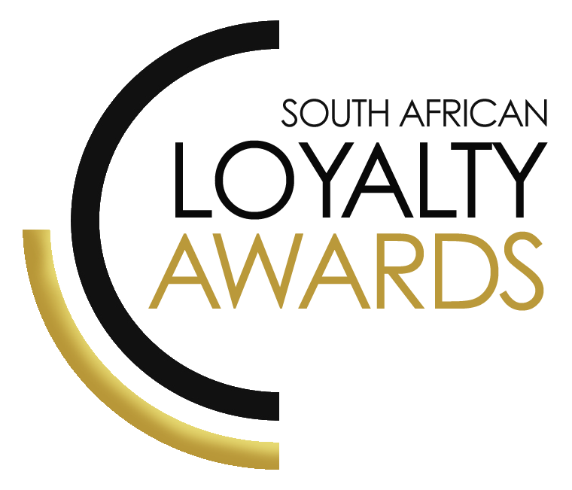
CATEGORY 9
BEST COMMUNITY OR ENVIRONMENTAL PROGRAMME / CAMPAIGN LINKED TO LOYALTY
ENTRY FORM

ENTRY CONTACT INFORMATION:
Company name:
Contact name:
Job title:
Business email:
Telephone number:
Company logo:
Permission to enter the Loyalty Awards:
(Signature)
Signed by:
(Name & Surname)
Role:
Date:
SUMMARY:
This award will be awarded to the brand which demonstrates their commitment to sustainability and who can demonstrate a high level of success in delivering a local or regional community loyalty initiatives. Entries will be judged according to the role the programme has played in caring for the environment and communities. Any community economic and social benefits should be highlighted. The loyalty programme or campaign must show their commitment and impact to community & sustainability initiatives, as well as, social, environmental, ethical practices and working with charities.
Please ensure your entries address the below criteria :
- Performance results of the programme or campaign
- Commitment and impact to community / environment / sustainability
- Enhanced value for members
- Frictionless customer experience
What we require :
- Entry contact information
- 1 Page executive summary
- Submission (max 3 pages)
- Supporting evidence files (max 5 items)
Entry fees:
A fee of R1 500 (ex VAT) is charged per category entry. Once you have submitted your entry, an invoice will be emailed to you. All entry fees must be paid in full before 1 June 2020.
AGENCY SUBMISSIONS (On behalf of clients)
If you are an agency and entering the awards on behalf of your client, you will need permission and sign-off from your client to enter their details for the awards. We require the signed agreement to accompany your entry. Please download the agency agreement here.
Please note: We will not review your entry if we have not received a signature from your client.
EXECUTIVE SUMMARY:

PROGRAMME OR CAMPAIGN:

RESULTS ACHIEVED:

THE NEXT 3 PAGES MUST HIGHLIGHT THE ACHIEVEMENTS IN THE FOLLOWING DELIVERABLES:

- Performance results of the programme or campaign
- Commitment and impact to community / environment / sustainability
- Enhanced value for members
- Frictionless customer experience

1. Performance results of the programme or campaign

2. Commitment and impact to community / environment / sustainability

3. Enhanced value for members

4. Frictionless customer experience

SAVING CRITERIA:
Once the above entry information has been completed, your files and supporting documentation must be saved in the following format when submitting your entry please:
file name = category#-programmename-brandname.doc
e.g. CATEGORY1-ROYALREWARDS-ROYALHOTEL.doc
Once you have saved all your files in the correct format, simply enter by emailing: info@southafricanloyaltyawards.com

If your file sizes are too big, simply send it to us via dropbox or wetransfer.
CONFIDENTIALITY:
To view our confidentiality agreement that has been signed by all judges and South African Loyalty Awards employees, please click here.
HAVE ANY QUESTIONS?
Give us a call on 021 761 48 10 or email info@southafricanloyaltyawards.com and we will gladly assist!

