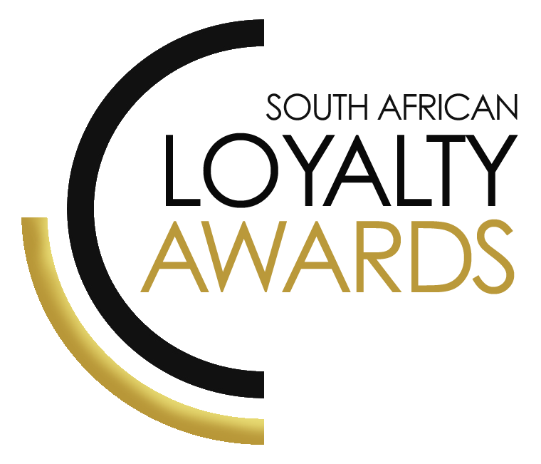
CATEGORY 15
BEST SHORT-TERM LOYALTY
MARKETING CAMPAIGN
OF THE YEAR 2022
ENTRY FORM

ENTRY CONTACT INFORMATION:
Company name:
Contact name:
Job title:
Business email:
Telephone number:
Company logo:
Permission to enter the Loyalty Awards:
(Signature)
Signed by:
(Name & Surname)
Role:
Date:
SUMMARY:
This award will go to the organisation or brand that can demonstrate how it has implemented the best marketing campaign linked to its loyalty programme or loyalty initiative. Brands must demonstrate how they have developed a winning campaign to address a challenge in the market place, utilise outstanding creative elements (which engages new or existing customers) and the use of relevant personalised communications.
Please ensure your entries address the below criteria:
- Increased commercial performance directly attributed to the campaign
- Enhanced customer value directly attributed to the campaign
- Enhanced customer experience
- Short term performance indicators which clearly lead to longer-term improvements in retention, average customer performance, engagement, etc.
What we require:
- Entry contact information
- 1 Page executive summary
- Submission (max 3 pages)
- Supporting evidence files (max 5 items)
Entry fees:
A fee of R1 950 (ex VAT) is charged per category entry. Once you have submitted your entry, an invoice will be emailed to you. All entry fees must be paid in full before 15 July 2022.
All entries must be emailed to: info@southafricanloyaltyawards.com
Should your file sizes be too big for email, please share via dropbox or wetransfer.
AGENCY SUBMISSIONS (On behalf of clients)
If you are an agency and entering the awards on behalf of your client, you will need permission and sign-off from your client to enter their details for the awards. We require the signed agreement to accompany your entry. Please download the agency agreement here.

EXECUTIVE SUMMARY:

CAMPAIGN DESCRIPTION:

RESULTS ACHIEVED:

THE NEXT 3 PAGES MUST HIGHLIGHT THE ACHIEVEMENTS IN THE FOLLOWING DELIVERABLES:

- Increased commercial performance directly attributed to the campaign
- Enhanced customer value directly attributed to the campaign
- Enhanced customer experience
- Short term performance indicators which clearly lead to longer-term improvements in retention, average customer performance, engagement, etc

Increased commercial performance directly attributed to the campaign:

Enhanced customer value directly attributed to the campaign

Enhanced customer experience:

Short term performance indicators which clearly lead to longer-term improvements in retention, average customer performance, engagement, etc

SAVING CRITERIA:
Once the above entry information has been completed, your files and supporting documentation must be saved in the following format when submitting your entry please:
file name = category#-programmename-brandname.doc
e.g. CATEGORY1-ROYALREWARDS-ROYALHOTEL.doc
Once you have saved all your files in the correct format, simply enter by emailing: info@southafricanloyaltyawards.com

If your file sizes are too big, simply send it to us via dropbox or wetransfer.
CONFIDENTIALITY:
To view our confidentiality agreement that has been signed by all judges and South African Loyalty Awards employees, please click here.
HAVE ANY QUESTIONS?
Please call us on 021 715 8619 or email info@southafricanloyaltyawards.com and we will gladly assist!

